Ujian Akhir Praktikum - Semester Ganjil 2020/2021
Practicum Final Exam –Odd Semester Year 2020/2021
Matakuliah  Subject |  |  | COMP6153 – Operating System |  |  | 
Kelas  Class | : | BI01 / BA08 / BH01 / BL01 / BK01 / BJ01 |  | Tanggal Mulai  Start Date | : 6 January 2021
Kelas  Class | : |  |  | Waktu Mulai  Start Time | : 15:20
Dosen  Lecturer | : | D1279 - Tatang Gunar Setiadji, M.Eng.  D2518 - Rony Baskoro Lukito, S.Kom., M.Kom  D3089 - Rubil, S.T., M.T.  D3366 - Bayu Kanigoro, S.Kom., M.T.  D4555 - Muhamad Fitra Kacamarga, S.Kom., M.T.I  D5970 - Wawiko Supeno, S.Si., MTI. |  | Tanggal Selesai  End Date | : 6 January 2021
Dosen  Lecturer | : |  |  | Waktu Selesai  End Time | : 17:20

PERATURAN UJIAN:
Exam Regulations:
- Mahasiswa tidak diperbolehkan berdiskusi dan/atau bekerja sama dengan peserta ujian lainnya
Student is not allowed to discuss and/or work together with other exam participants
- Mahasiswa tidak diperbolehkan untuk membuka dan menyalin dari BUKU atau CATATAN, VIDEO dari pengajar (recording kelas, VBL, Youtube, dsb) dan REFERENSI lainnya
Student isn't allowed to open and copy from any resources such as notes, videos (class recording, VBL, Youtube, etc) and other references
- Mahasiswa tidak diperbolehkan membuka dan menyalin jawaban dari internet (google, stackoverflow, dsb)
Student isn't allowed to open and copy answer from the internet (google, stackoverflow, etc)
- Asisten BERHAK memberi nilai 0 (NOL) bagi peserta ujian yang melakukan segala bentuk kecurangan
Assistant is able to give 0 (ZERO) score for exam participant who does any cheating actions
- Kumpulkan jawaban tepat pada waktunya, apabila terlambat mengumpulkan maka jawaban tidak akan dikoreksi dan nilai mahasiswa adalah 0
Submit the answer on time, if not, then the answer will not be checked, and the students will receive 0 (ZERO)
- Bila Anda tidak membaca peraturan ini, maka Anda dianggap telah membaca dan menyetujuinya
If you have missed to read these regulations, so you are considered to have read and agreed on it



SOFTWARE YANG DIGUNAKAN:
Software will be used:
- Java 8
- Eclipse 2020.6
- NachOS 5.0j

FILE YANG DIKUMPULKAN:
File must be collected:
- *.java
- *.class

PERHATIAN!
Attention!
- Bagi yang mengerjakan tidak sesuai dengan soal, maka akan diberikan nilai NOL (0)
For those who do not work in accordance with the exam case will be marked as ZERO (0)
- Bagi yang mengerjakan tidak sesuai dengan software dan versi yang telah ditetapkan, maka akan tetap dikoreksi dengan software dan versi yang telah ditetapkan
For those who do not work in accordance with the software and specific version will be corrected by the predefined software and version
- Kompres semua jawaban yang akan diunggah. Pastikan format pengumpulan nama file dan ekstensi sesuai dengan format berikut: [NIM]-[NAMA].zip
Compress all file that will be uploaded. Make sure the format for collecting file name and extension according to the following format: [NIM]-[NAME].zip

Soal
Case

Important Notes:
- Use your own Console and Scheduler (FIFO)
- You must use Semaphore to control operation
- You must use Timer to generate tick of time
- Use KThread

FigiMon Dex
FigiMon Dex is a database that stores data about FigiMon, which are monsters that live in computers. The FigiMon Dex are made to help user to know what kind of type is a FigiMon by managing the data of FigiMon in the FigiMon Dex itself. Users can insert, view, and delete data from the FigiMon Dex. As a trusted programmer, you are asked to create the application using nachOS in Java programming language.

In the start of the application, the program will look for a file named “FigiMonDex.txt”. If the file is not found, then the program will first create the file. If the file exists, then the program should not make a new file or overwrite the old file.
After the said process has been done, the application will then show 4 menus which represent features in the application which are:
- Insert Data
- View Data
- Delete Data
- Exit
Figure 1. Main menu

- Insert Data
The first option will give the user the ability to insert new data into the file system. This option requires the user to input data of the FigiMon that follows the following detail which are:
- Ask the user to input FigiMon Name. The FigiMon name must ends with “mon”.
Figure 2. Name input
- Ask the user to input FigiMon Type. The FigiMon type must be either “Vaccine”, “Data”, or “Virus” (Case Sensitive).
Figure 3. Type input

- After all the required input has been filled, save the input to file named “FigiMonDex.txt” with the following format.

[FigiMon Name]#[FigiMon Type]

- View Data
The second option will give user the ability to view all data read by the file system. The process follows the following steps which are:
- Check if FigiMon list has any data. If the FigiMon list didn’t have any data, the application will show an error message to the user.
Figure 4. View validation

- Otherwise, if the FigiMon list has some data, the application will show all of the data using KThread and Scheduler (FIFO concept). The data will be shown with delay of 500 milliseconds (using Thread sleep).
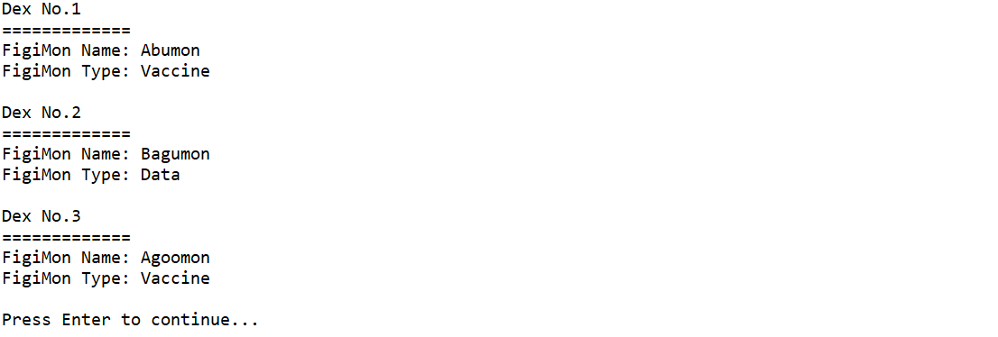
Figure 5. View all data

- Delete Data
The third option will give the user the ability to delete data from the file system. The deleting process follows the following steps which are:
- Check if FigiMon list has any data. If the FigiMon list didn’t have any data, the application will show an error message to the user.
Figure 6. Delete validation

- Otherwise, the application will print all FigiMon on FigiMon list and ask the user what index of data that they want to delete. The deleted index starts from 1 to FigiMon list data size. Validate the input must be between that range.

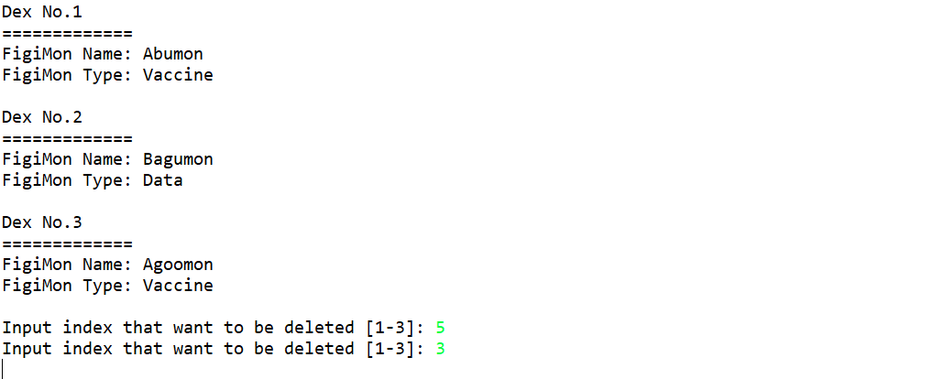

Figure 7. Delete data

- After data deletion has been completed successfully, update the data in file “FigiMonDex.txt” and direct the user back to the main menu.

- Exit
If the user chooses the fourth option, the application will print tick of time using a timer and show the user a message that says: “Thank you for using the FigiMon Dex!”.
Figure 8. Exit

